Technical challenge

Group 5

2024-08-03

Table of Contents

#Setup for the project

*# Set global chunk options*  
knitr**::**opts_chunk**$set**(echo = TRUE, error = TRUE, warning = TRUE, message = TRUE)  
*# Set working directory if necessary*  
**getwd**()

## [1] "C:/Users/nkemj/OneDrive/Documents"

# Load packages

**library**(tidyverse)

## ── Attaching core tidyverse packages ──────────────────────── tidyverse 2.0.0 ──  
## ✔ dplyr 1.1.4 ✔ readr 2.1.5  
## ✔ forcats 1.0.0 ✔ stringr 1.5.1  
## ✔ ggplot2 3.5.1 ✔ tibble 3.2.1  
## ✔ lubridate 1.9.3 ✔ tidyr 1.3.1  
## ✔ purrr 1.0.2   
## ── Conflicts ────────────────────────────────────────── tidyverse_conflicts() ──  
## ✖ dplyr::filter() masks stats::filter()  
## ✖ dplyr::lag() masks stats::lag()  
## ℹ Use the conflicted package (<http://conflicted.r-lib.org/>) to force all conflicts to become errors

**library**(survey)

## Loading required package: grid  
## Loading required package: Matrix  
##   
## Attaching package: 'Matrix'  
##   
## The following objects are masked from 'package:tidyr':  
##   
## expand, pack, unpack  
##   
## Loading required package: survival  
##   
## Attaching package: 'survey'  
##   
## The following object is masked from 'package:graphics':  
##   
## dotchart

*#library(patchwork)*

#Import data

diabetes_data <- **read.csv**("C:/Users/nkemj/Downloads/Challenge Datasets.csv")  
  
  
**View**(diabetes_data)  
  
  
*#Recode the variables*  
  
diabetes_data <- diabetes_data **%>%**  
 **mutate**(  
 hypertension = **factor**(hypertension, levels = **c**(1, 2, 3, 4, 7, 9), labels = **c**("Yes", "Yes, but female told only during pregnancy", "No", "Told borderline high or pre-hypertensive or elevated blood pressure ", "Don't Know/Not Sure", "Refused")),  
 high_cholesterol = **factor**(high_cholesterol, levels= **c**(1, 2, 7, 9), labels = **c**("Yes", "No", "Don't Know/Not Sure", "Refused")),  
 cholesterol_medication= **factor**(cholesterol_medication, levels = **c**(1, 2, 7, 9), labels = **c**("Yes", "No", "Don't Know", "Refused")),  
 myocardial_infarction = **factor**( myocardial_infarction, levels = **c**(1, 2, 7, 9), labels= **c**("Yes", "No", "Don't Know/Not Sure", "Refused")),  
 coronary_heart_dx = **factor**(coronary_heart_dx, levels = **c**(1, 2, 7, 9), labels= **c**("Yes", "No", "Don't Know/Not Sure", "Refused")),  
 asthma = **factor**( asthma, levels = **c**(1, 2, 7, 9), labels= **c**("Yes", "No", "Don't Know/Not Sure", "Refused")),  
 skin_cancer = **factor**( skin_cancer, levels = **c**(1, 2, 7, 9), labels= **c**("Yes", "No", "Don't Know/Not Sure", "Refused")),  
 any_other_cancer = **factor**( any_other_cancer, levels = **c**(1, 2, 7, 9), labels= **c**("Yes", "No", "Don't Know/Not Sure", "Refused")),  
 copd = **factor**( copd, levels = **c**(1, 2, 7, 9), labels= **c**("Yes", "No", "Don't Know/Not Sure", "Refused")),  
 kidney_disease = **factor**( kidney_disease, levels = **c**(1, 2, 7, 9), labels= **c**("Yes", "No", "Don't Know/Not Sure", "Refused")),  
 diabetes_mellitus = **factor**( diabetes_mellitus, levels = **c**(1, 2, 3, 4, 7, 9), labels= **c**("Yes", "Yes, but female told only during pregnancy ","No","No, pre-diabetes or borderline diabetes", "Don't Know/Not Sure", "Refused")),  
 arthritis = **factor**( arthritis, levels = **c**(1, 2), labels= **c**("Diagnosed with arthritis ", "Not diagnosed with arthritis")),  
 marital_status = **factor**(marital_status, levels = **c**(1, 2, 3, 4, 5, 6, 9), labels = **c**("Married", "Divorced", "Widowed", "Separated", "Never Married", "A member of an unmarried couple", "Refused")),  
 deaf = **factor**( deaf, levels = **c**(1, 2, 7, 9), labels= **c**("Yes", "No", "Don't Know/Not Sure", "Refused")),  
 blind = **factor**( blind, levels = **c**(1, 2, 7, 9), labels= **c**("Yes", "No", "Don't Know/Not Sure", "Refused")),  
 difficulty_walking = **factor**( difficulty_walking, levels = **c**(1, 2, 7, 9), labels= **c**("Yes", "No", "Don't Know/Not Sure", "Refused")),  
 hiv_aids = **factor**( hiv_aids, levels = **c**(1, 2, 7, 9), labels= **c**("Yes", "No", "Don't Know/Not Sure", "Refused")),  
 caregiver = **factor**( caregiver, levels = **c**(1, 2, 7, 8, 9), labels= **c**("Yes", "No", "Don't Know/Not Sure","Caregiving recipient died in past 30 days", "Refused")),   
 sex = **factor**( sex, levels = **c**(1, 2, 7, 9), labels= **c**("Male", "Female", "Don't Know/Not Sure", "Refused")),  
 sexual_orientation = **factor**( sexual_orientation, levels = **c**(1, 2, 3, 4, 7, 9), labels= **c**("Gay", "Straight","Bisexual", "Something else", "Don't Know/Not Sure", "Refused")),  
 ethnicity = **factor**( ethnicity, levels = **c**(1, 2, 3, 4, 5, 6), labels= **c**("White, Non-Hispanic", "Black, Non-Hispanic", "Asian, Non-Hispanic ", "American Indian/Alaskan Native, Non-Hispanic", "Hispanic", "Other race")),  
 physical_activity = **factor**(physical_activity, levels = **c**(1, 2, 9), labels = **c**("Had physical activity or exercise ", "No physical activity or exercise in last 30 days", "Don’t know/Refused/Missing")),  
 chd_or_mi = **factor**(chd_or_mi, levels = **c**(1, 2), labels = **c**("Reported having MI or CHD", "Did not report having MI or CHD")),  
 smoking_status = **factor**(smoking_status, levels = **c**(1, 2, 3, 4, 9), labels = **c**("Current smoker - now smokes every day", "Current smoker - now smokes some days", "Former smoker", "Never Smoked", "Don't Know/Refused/Missing"))  
  
)   
  
*# Check fo missing values*  
missing_values<- **sum**(**is.na**(diabetes_data))  
missing_values

## [1] 2126583

*# Check for duplicate rows*  
duplicate_rows<- **sum**(**duplicated**(diabetes_data))  
duplicate_rows

## [1] 0

*# Set options for allowing a single observation per stratum*  
**options**(survey.lonely.psu = "adjust")  
  
*# Create survey design object to account for complex survey design*  
  
data_design <- **svydesign**(id = **~**1, strata = **~**X_STSTR, weights = **~**X_LLCPWT, data = diabetes_data)

#Data Exploration

*#Total number of patients with diabetes*  
  
diabetes_total <- diabetes_data **%>%**  
 **count**(diabetes_mellitus) **%>%**  
 **mutate**(percentage = **round**(n **/sum**(n) **\*** 100,0))  
  
**print**(diabetes_total)

## diabetes_mellitus n percentage  
## 1 Yes 57616 13  
## 2 Yes, but female told only during pregnancy 3808 1  
## 3 No 366342 84  
## 4 No, pre-diabetes or borderline diabetes 9942 2  
## 5 Don't Know/Not Sure 613 0  
## 6 Refused 369 0  
## 7 <NA> 3 0

*#calculate the diabetes prevalence of the weighted variables*  
weighted_total <- **svymean**(**~**diabetes_mellitus, data_design, na.rm = TRUE)  
  
***##Confidence Interval***  
  
overall_ci <- **confint**(weighted_total)  
  
*# Print overall prevalence*  
**cat**("Total diabetes:",   
 **format**(**round**(weighted_total[1] **\*** 100, 1), nsmall = 1), "%",  
 "(95% CI:",   
 **format**(**round**(overall_ci[1] **\*** 100, 1), nsmall = 1), "-",  
 **format**(**round**(overall_ci[2] **\*** 100, 1), nsmall = 1), "%)**\n\n**")

## Total diabetes: 11.4 % (95% CI: 11.1 - 0.9 %)

*# Plot the total diabetes*   
diabetes_total **%>%**  
 **ggplot**(**aes**(diabetes_mellitus, n)) **+**  
 **geom_bar**(stat = "identity", fill = "blue", width = 0.7 ) **+**   
 **labs**(  
 title = "Total Diabetes Patient",  
 x = "Diabetes Status",  
 y = "Frequency") **+**  
 **theme_minimal**() **+**  
 **theme**(axis.text.x = **element_text**(angle = 45, hjust = 1)) **+**   
 **theme**(panel.grid.major = **element_blank**(),  
 panel.grid.minor = **element_blank**())

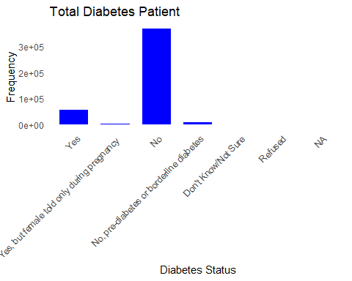

*#Diabetes patient by ethnicity*  
  
  
Dia_eth <- **svyby**(**~**diabetes_mellitus, **~**ethnicity, data_design, svymean, na.rm = TRUE)  
  
  
*#calculate Confidence Interval*   
ethnicity_ci <- **confint**(Dia_eth)  
  
*#The value of ethnicity_ci gives the result of all the outcome variables to get the exact prevalence, we created a subset of the first 6 rows where diabetes = yes.*  
  
ethnicity_ci_subset <- ethnicity_ci[1**:**6,]  
  
*# Combine the results*  
ethnicity_results <- **data.frame**(  
 Ethnicity = Dia_eth**$**ethnicity,  
 Diabetes = Dia_eth**$**diabetes_mellitusYes **\*** 100,  
 CI_Lower = ethnicity_ci_subset[, 1] **\*** 100,  
 CI_Upper = ethnicity_ci_subset[, 2] **\*** 100  
)  
  
  
*# Print results*   
**for**(i **in** 1**:nrow**(ethnicity_results)) {  
 **cat**(ethnicity_results**$**Ethnicity[i], ":",   
 **format**(**round**(ethnicity_results**$**Diabetes[i], 1), nsmall = 1), "%",  
 "(95% CI:",   
 **format**(**round**(ethnicity_results**$**CI_Lower[i], 1), nsmall = 1), "-",  
 **format**(**round**(ethnicity_results**$**CI_Upper[i], 1), nsmall = 1), "%)**\n**")  
}

## 1 : 10.5 % (95% CI: 10.3 - 10.7 %)  
## 2 : 15.5 % (95% CI: 14.8 - 16.2 %)  
## 3 : 9.6 % (95% CI: 8.2 - 11.0 %)  
## 4 : 14.8 % (95% CI: 13.4 - 16.2 %)  
## 5 : 12.1 % (95% CI: 11.4 - 12.7 %)  
## 6 : 10.7 % (95% CI: 9.6 - 11.9 %)

*# Plot Diabetes by ethnicity*   
**ggplot**(ethnicity_results, **aes**(x = Ethnicity, y = Diabetes)) **+**  
 **geom_bar**(stat = "identity", fill = "blue", width = 0.5) **+**  
 **labs**(  
 title = "Diabetes by Ethnicity",  
 x = "Ethnicity",  
 y = "Diabetes"  
 ) **+**  
 **theme_minimal**() **+**  
 **theme**(axis.text.x = **element_text**(angle = 45, hjust = 1)) **+**   
 **theme**(panel.grid.major = **element_blank**(),  
 panel.grid.minor = **element_blank**())

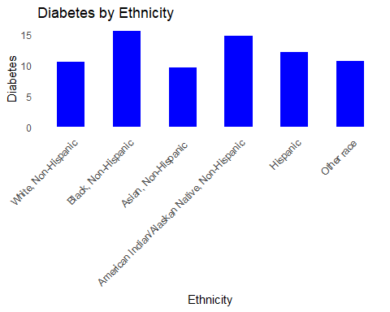

*#Diabetes patient by Gender*  
  
  
Gender <- **svyby**(**~**diabetes_mellitus, **~**sex, data_design, svymean, na.rm = TRUE)  
  
  
*#calculate Confidence Interval*   
Gender_ci <- **confint**(Gender)  
  
*#The value of Gender_ci gives the result of all the outcome variables to get the exact prevalence, we created a subset of the first 4 rows where diabetes = yes.*  
  
Gender_ci_subset <- Gender_ci[1**:**4,]  
  
*# Combine the results*  
Gender_results <- **data.frame**(  
 gender = Gender**$**sex,  
 Diabetes = Gender**$**diabetes_mellitusYes **\*** 100,  
 CI_Lower = Gender_ci_subset[, 1] **\*** 100,  
 CI_Upper = Gender_ci_subset[, 2] **\*** 100  
)  
  
  
*# Print results*   
**for**(i **in** 1**:nrow**(Gender_results)) {  
 **cat**(Gender_results**$**gender[i], ":",   
 **format**(**round**(Gender_results**$**Diabetes[i], 1), nsmall = 1), "%",  
 "(95% CI:",   
 **format**(**round**(Gender_results**$**CI_Lower[i], 1), nsmall = 1), "-",  
 **format**(**round**(Gender_results**$**CI_Upper[i], 1), nsmall = 1), "%)**\n**")  
}

## 1 : 12.2 % (95% CI: 11.7 - 12.7 %)  
## 2 : 11.1 % (95% CI: 10.6 - 11.5 %)  
## 3 : 19.5 % (95% CI: 6.2 - 32.8 %)  
## 4 : 10.1 % (95% CI: 5.0 - 15.2 %)

*# Plot Diabetes by ethnicity*   
**ggplot**(Gender_results, **aes**(x = gender, y = Diabetes)) **+**  
 **geom_bar**(stat = "identity", fill = "green", width = 0.5) **+**  
 **labs**(  
 title = "Diabetes by Gender",  
 x = "Gender",  
 y = "Diabetes"  
 ) **+**  
 **theme_minimal**() **+**  
 **theme**(axis.text.x = **element_text**(angle = 45, hjust = 1)) **+**   
 **theme**(panel.grid.major = **element_blank**(),  
 panel.grid.minor = **element_blank**())

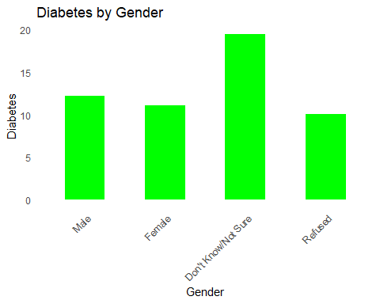

*#Diabetes patient by Smoking Status*  
  
  
smoking <- **svyby**(**~**diabetes_mellitus, **~**smoking_status, data_design, svymean, na.rm = TRUE)  
  
  
*#calculate Confidence Interval*   
smoking_ci <- **confint**(smoking)  
  
*#The value of smoking_ci gives the result of all the outcome variables to get the exact prevalence, we created a subset of the first 5 rows where diabetes = yes.*  
  
smoking_ci_subset <- smoking_ci[1**:**5,]  
  
*# Combine the results*  
smoking_results <- **data.frame**(  
 Smoking = smoking**$**smoking_status,  
 Diabetes = smoking**$**diabetes_mellitusYes **\*** 100,  
 CI_Lower = smoking_ci_subset[, 1] **\*** 100,  
 CI_Upper = smoking_ci_subset[, 2] **\*** 100  
)  
  
  
*# Print results*   
**for**(i **in** 1**:nrow**(smoking_results)) {  
 **cat**(smoking_results**$**Smoking[i], ":",   
 **format**(**round**(smoking_results**$**Diabetes[i], 1), nsmall = 1), "%",  
 "(95% CI:",   
 **format**(**round**(smoking_results**$**CI_Lower[i], 1), nsmall = 1), "-",  
 **format**(**round**(smoking_results**$**CI_Upper[i], 1), nsmall = 1), "%)**\n**")  
}

## 1 : 11.9 % (95% CI: 11.2 - 12.5 %)  
## 2 : 10.8 % (95% CI: 9.7 - 11.9 %)  
## 3 : 15.6 % (95% CI: 15.1 - 16.0 %)  
## 4 : 9.8 % (95% CI: 9.6 - 10.1 %)  
## 5 : 10.3 % (95% CI: 9.4 - 11.2 %)

*# Plot Diabetes by smoking*  
**ggplot**(smoking_results, **aes**(x = Smoking, y = Diabetes)) **+**  
 **geom_bar**(stat = "identity", fill = "orange", width = 0.5) **+**  
 **labs**(  
 title = "Diabetes by smoking status",  
 x = "Smoking Status",  
 y = "Diabetes"  
 ) **+**  
 **theme_minimal**() **+**  
 **theme**(axis.text.x = **element_text**(angle = 45, hjust = 1)) **+**   
 **theme**(panel.grid.major = **element_blank**(),  
 panel.grid.minor = **element_blank**())

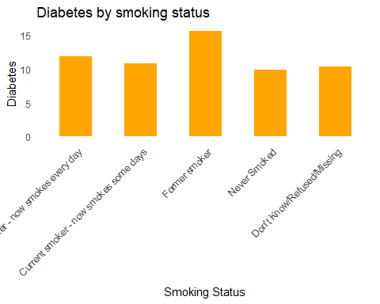 #Comorbidities

*#Diabetes and hypertension*  
  
Dia_hyp <- **svyby**(**~**diabetes_mellitus, **~**hypertension, data_design, svymean, na.rm = TRUE)  
  
**print**(Dia_hyp)

## hypertension  
## Yes Yes  
## Yes, but female told only during pregnancy Yes, but female told only during pregnancy  
## No No  
## Told borderline high or pre-hypertensive or elevated blood pressure Told borderline high or pre-hypertensive or elevated blood pressure   
## Don't Know/Not Sure Don't Know/Not Sure  
## Refused Refused  
## diabetes_mellitusYes  
## Yes 0.24411949  
## Yes, but female told only during pregnancy 0.06490515  
## No 0.04924415  
## Told borderline high or pre-hypertensive or elevated blood pressure 0.08364222  
## Don't Know/Not Sure 0.12029725  
## Refused 0.06197352  
## diabetes_mellitusYes, but female told only during pregnancy   
## Yes 0.006584214  
## Yes, but female told only during pregnancy 0.097438007  
## No 0.010393223  
## Told borderline high or pre-hypertensive or elevated blood pressure 0.008576644  
## Don't Know/Not Sure 0.008645223  
## Refused 0.002994835  
## diabetes_mellitusNo  
## Yes 0.7097617  
## Yes, but female told only during pregnancy 0.8160211  
## No 0.9228545  
## Told borderline high or pre-hypertensive or elevated blood pressure 0.8060398  
## Don't Know/Not Sure 0.7429432  
## Refused 0.6655488  
## diabetes_mellitusNo, pre-diabetes or borderline diabetes  
## Yes 0.03734821  
## Yes, but female told only during pregnancy 0.02103858  
## No 0.01594585  
## Told borderline high or pre-hypertensive or elevated blood pressure 0.10059256  
## Don't Know/Not Sure 0.09622121  
## Refused 0.01997729  
## diabetes_mellitusDon't Know/Not Sure  
## Yes 0.0018675986  
## Yes, but female told only during pregnancy 0.0002139258  
## No 0.0012237493  
## Told borderline high or pre-hypertensive or elevated blood pressure 0.0011487266  
## Don't Know/Not Sure 0.0267294487  
## Refused 0.0141285427  
## diabetes_mellitusRefused  
## Yes 0.0003187959  
## Yes, but female told only during pregnancy 0.0003832305  
## No 0.0003385447  
## Told borderline high or pre-hypertensive or elevated blood pressure 0.0000000000  
## Don't Know/Not Sure 0.0051636861  
## Refused 0.2353769876  
## se.diabetes_mellitusYes  
## Yes 0.0023857390  
## Yes, but female told only during pregnancy 0.0129935190  
## No 0.0009479911  
## Told borderline high or pre-hypertensive or elevated blood pressure 0.0113090264  
## Don't Know/Not Sure 0.0244673753  
## Refused 0.0121850958  
## se.diabetes_mellitusYes, but female told only during pregnancy   
## Yes 0.0003624858  
## Yes, but female told only during pregnancy 0.0106453452  
## No 0.0004969470  
## Told borderline high or pre-hypertensive or elevated blood pressure 0.0023559863  
## Don't Know/Not Sure 0.0038467529  
## Refused 0.0016884117  
## se.diabetes_mellitusNo  
## Yes 0.002546150  
## Yes, but female told only during pregnancy 0.016041841  
## No 0.001220521  
## Told borderline high or pre-hypertensive or elevated blood pressure 0.016287600  
## Don't Know/Not Sure 0.053501180  
## Refused 0.034503358  
## se.diabetes_mellitusNo, pre-diabetes or borderline diabetes  
## Yes 0.0012257987  
## Yes, but female told only during pregnancy 0.0049201546  
## No 0.0006342104  
## Told borderline high or pre-hypertensive or elevated blood pressure 0.0133081970  
## Don't Know/Not Sure 0.0569453634  
## Refused 0.0107550140  
## se.diabetes_mellitusDon't Know/Not Sure  
## Yes 0.0001989126  
## Yes, but female told only during pregnancy 0.0001443621  
## No 0.0001381365  
## Told borderline high or pre-hypertensive or elevated blood pressure 0.0008096460  
## Don't Know/Not Sure 0.0075247096  
## Refused 0.0081898394  
## se.diabetes_mellitusRefused  
## Yes 7.118387e-05  
## Yes, but female told only during pregnancy 2.765838e-04  
## No 6.021692e-05  
## Told borderline high or pre-hypertensive or elevated blood pressure 0.000000e+00  
## Don't Know/Not Sure 3.048990e-03  
## Refused 2.948478e-02

*#calculate Confidence Interval*   
dia_hyp_ci <- **confint**(Dia_hyp)  
  
*#The value of dia_hyp_ci gives the result of all the outcome variables to get the exact prevalence, we created a subset of the first 6 rows where diabetes = yes.*  
  
dia_hyp_ci_subset <- dia_hyp_ci[1**:**6,]  
  
*# Combine the results*  
dia_hyp_results <- **data.frame**(  
 Hypertension = Dia_hyp**$**hypertension,  
 Diabetes = Dia_hyp**$**diabetes_mellitusYes **\*** 100,  
 CI_Lower = dia_hyp_ci_subset[, 1] **\*** 100,  
 CI_Upper = dia_hyp_ci_subset[, 2] **\*** 100  
)  
  
  
*# Print results*   
**for**(i **in** 1**:nrow**(dia_hyp_results)) {  
 **cat**(dia_hyp_results**$**Hypertension[i], ":",   
 **format**(**round**(dia_hyp_results**$**Diabetes[i], 1), nsmall = 1), "%",  
 "(95% CI:",   
 **format**(**round**(dia_hyp_results**$**CI_Lower[i], 1), nsmall = 1), "-",  
 **format**(**round**(dia_hyp_results**$**CI_Upper[i], 1), nsmall = 1), "%)**\n**")  
}

## 1 : 24.4 % (95% CI: 23.9 - 24.9 %)  
## 2 : 6.5 % (95% CI: 3.9 - 9.0 %)  
## 3 : 4.9 % (95% CI: 4.7 - 5.1 %)  
## 4 : 8.4 % (95% CI: 6.1 - 10.6 %)  
## 5 : 12.0 % (95% CI: 7.2 - 16.8 %)  
## 6 : 6.2 % (95% CI: 3.8 - 8.6 %)

*# Plot Diabetes by hypertension*   
**ggplot**(dia_hyp_results, **aes**(x = Hypertension, y = Diabetes)) **+**  
 **geom_bar**(stat = "identity", fill = "red", width = 0.5) **+**  
 **labs**(  
 title = "Diabetes & Hypertension",  
 x = "Hypertension",  
 y = "Diabetes"  
 ) **+**  
 **theme_minimal**() **+**  
 **theme**(axis.text.x = **element_text**(angle = 45, hjust = 1)) **+**   
 **theme**(panel.grid.major = **element_blank**(),  
 panel.grid.minor = **element_blank**())

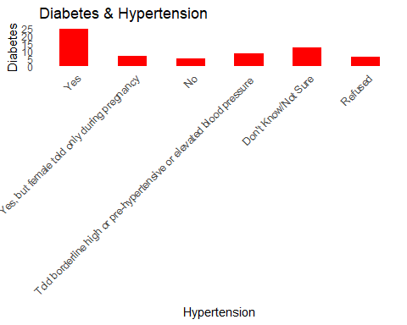

*#Diabetes and High cholesterol*  
  
Dia_chol <- **svyby**(**~**diabetes_mellitus, **~**high_cholesterol, data_design, svymean, na.rm = TRUE)  
  
  
*#calculate Confidence Interval*   
dia_chol_ci <- **confint**(Dia_chol)  
  
*#The value of dia_chol_ci gives the result of all the outcome variables to get the exact prevalence, we created a subset of the first 6 rows where diabetes = yes.*  
  
dia_chol_ci_subset <- dia_chol_ci[1**:**4,]  
  
dia_chol_ci_subset2 <- dia_chol_ci[5**:**8,]  
  
*# Combine the results*  
dia_chol_results <- **data.frame**(  
 High_cholesterol = Dia_chol**$**high_cholesterol,  
 Diabetes = Dia_chol**$**diabetes_mellitusYes **\*** 100,  
 Diabetes2 = Dia_chol**$**`diabetes_mellitusYes, but female told only during pregnancy `**\*** 100,  
 CI_Lower = dia_chol_ci_subset[, 1] **\*** 100,  
 CI_Upper = dia_chol_ci_subset[, 2] **\*** 100  
)  
  
  
*# Combine the results for diabetes 2*  
dia_chol_results2 <- **data.frame**(  
 High_cholesterol = Dia_chol**$**high_cholesterol,  
 Diabetes2 = Dia_chol**$**`diabetes_mellitusYes, but female told only during pregnancy `**\*** 100,  
 CI_Lower = dia_chol_ci_subset2[, 1] **\*** 100,  
 CI_Upper = dia_chol_ci_subset2[, 2] **\*** 100  
)  
  
  
  
*# Print results*   
**for**(i **in** 1**:nrow**(dia_chol_results)) {  
 **cat**(dia_chol_results**$**High_cholesterol[i], ":",   
 **format**(**round**(dia_chol_results**$**Diabetes[i], 1), nsmall = 1),  
 "%",  
 "(95% CI:",   
 **format**(**round**(dia_chol_results**$**CI_Lower[i], 1), nsmall = 1), "-",  
 **format**(**round**(dia_chol_results**$**CI_Upper[i], 1), nsmall = 1), "%)**\n**")  
}

## 1 : 22.7 % (95% CI: 22.2 - 23.2 %)  
## 2 : 7.6 % (95% CI: 7.4 - 7.9 %)  
## 3 : 16.3 % (95% CI: 13.3 - 19.3 %)  
## 4 : 10.3 % (95% CI: 5.3 - 15.2 %)

*#print results for diabetes 2*  
**for**(i **in** 1**:nrow**(dia_chol_results2)) {  
 **cat**(dia_chol_results2**$**High_cholesterol[i], ":",   
 **format**(**round**(dia_chol_results2**$**Diabetes2[i], 1), nsmall = 1),  
 "%",  
 "(95% CI:",   
 **format**(**round**(dia_chol_results2**$**CI_Lower[i], 1), nsmall = 1), "-",  
 **format**(**round**(dia_chol_results2**$**CI_Upper[i], 1), nsmall = 1), "%)**\n**")  
}

## 1 : 0.8 % (95% CI: 0.7 - 1.0 %)  
## 2 : 1.1 % (95% CI: 1.0 - 1.2 %)  
## 3 : 0.9 % (95% CI: 0.3 - 1.4 %)  
## 4 : 0.7 % (95% CI: 0.0 - 1.4 %)

*# Plot Diabetes by High_cholesterol*  
 **ggplot**(dia_chol_results, **aes**(x = High_cholesterol, y = Diabetes)) **+**  
 **geom_bar**(stat = "identity", fill = "red", width = 0.5) **+**  
 **labs**(  
 title = "Diabetes & High_cholesterol",  
 x = "Hypertension",  
 y = "Diabetes"  
 ) **+**  
 **theme_minimal**() **+**  
 **theme**(axis.text.x = **element_text**(angle = 45, hjust = 1)) **+**   
 **theme**(panel.grid.major = **element_blank**(),  
 panel.grid.minor = **element_blank**())

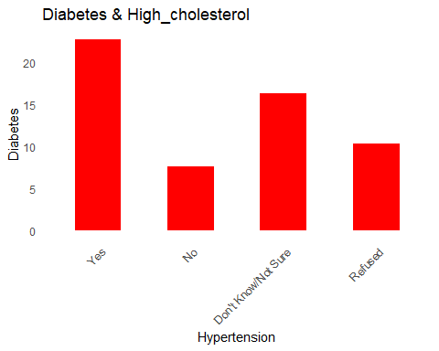

**ggplot**(dia_chol_results, **aes**(x = High_cholesterol, y = Diabetes2)) **+**  
 **geom_bar**(stat = "identity", fill = "yellow", width = 0.5) **+**  
 **labs**(  
 title = "Diabetes2 & High_Cholesterol",  
 x = "High_cholesterol",  
 y = "Diabetes"  
 ) **+**  
 **theme_minimal**() **+**  
 **theme**(axis.text.x = **element_text**(angle = 45, hjust = 1)) **+**   
 **theme**(panel.grid.major = **element_blank**(),  
 panel.grid.minor = **element_blank**())

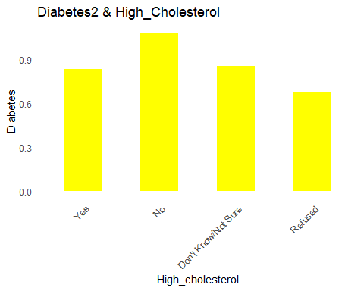

*# Display both charts side by side with the patchwork package*  
*#p1 + p2*

#Comorbidities

*#Diabetes and myocardial_infarction*  
  
Dia_myo <- **svyby**(**~**diabetes_mellitus, **~**myocardial_infarction, data_design, svymean, na.rm = TRUE)  
  
  
*#calculate Confidence Interval*   
dia_myo_ci <- **confint**(Dia_myo)  
  
*#The value of dia_myo_ci gives the result of all the outcome variables to get the exact prevalence, we created a subset of the first 6 rows where diabetes = yes.*  
  
dia_myo_ci_subset <- dia_myo_ci[1**:**4,]  
  
*# Combine the results*  
dia_myo_results <- **data.frame**(  
 Myocardial_infarction = Dia_myo**$**myocardial_infarction,  
 diabetes = Dia_myo**$**diabetes_mellitusYes **\*** 100,  
 diabetes2 = Dia_myo**$**`diabetes_mellitusYes, but female told only during pregnancy `**\***100,  
 CI_Lower = dia_myo_ci_subset[, 1] **\*** 100,  
 CI_Upper = dia_myo_ci_subset[, 2] **\*** 100  
)  
  
  
  
*# Print results*   
**for**(i **in** 1**:nrow**(dia_myo_results)) {  
 **cat**(dia_myo_results**$**Myocardial_infarction[i], ":",   
 **format**(**round**(dia_myo_results**$**diabetes[i], 1), nsmall = 1), "%",  
 "(95% CI:",   
 **format**(**round**(dia_myo_results**$**CI_Lower[i], 1), nsmall = 1), "-",  
 **format**(**round**(dia_myo_results**$**CI_Upper[i], 1), nsmall = 1), "%)**\n**")  
}

## 1 : 35.4 % (95% CI: 34.0 - 36.8 %)  
## 2 : 10.3 % (95% CI: 10.1 - 10.5 %)  
## 3 : 18.3 % (95% CI: 15.1 - 21.4 %)  
## 4 : 2.4 % (95% CI: 1.0 - 3.8 %)

*# Plot Diabetes by Myocardinal*   
**ggplot**(dia_myo_results, **aes**(x = Myocardial_infarction, y = diabetes)) **+**  
 **geom_bar**(stat = "identity", fill = "purple", width = 0.5) **+**  
 **labs**(  
 title = "Diabetes & Myocardial_infarction",  
 x = "Myocardial_infarction",  
 y = "Diabetes"  
 ) **+**  
 **theme_minimal**() **+**  
 **theme**(axis.text.x = **element_text**(angle = 45, hjust = 1)) **+**   
 **theme**(panel.grid.major = **element_blank**(),  
 panel.grid.minor = **element_blank**())

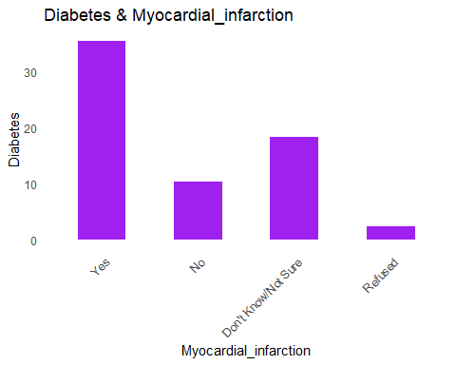

*#Diabetes and Skin cancer*  
  
Dia_cancer <- **svyby**(**~**diabetes_mellitus, **~**skin_cancer, data_design, svymean, na.rm = TRUE)  
  
  
*#calculate Confidence Interval*   
dia_cancer_ci <- **confint**(Dia_cancer)  
  
*#The value of dia_cancer_ci gives the result of all the outcome variables to get the exact prevalence, we created a subset of the first 6 rows where diabetes = yes.*  
  
dia_cancer_ci_subset <- dia_cancer_ci[1**:**4,]  
  
*# Combine the results*  
dia_cancer_results <- **data.frame**(  
 Skin_cancer = Dia_cancer**$**skin_cancer,  
 diabetes = Dia_cancer**$**diabetes_mellitusYes **\*** 100,  
 diabetes2 = Dia_cancer**$**`diabetes_mellitusYes, but female told only during pregnancy `**\***100,  
 CI_Lower = dia_cancer_ci_subset[, 1] **\*** 100,  
 CI_Upper = dia_cancer_ci_subset[, 2] **\*** 100  
)  
  
  
  
*# Print results*   
**for**(i **in** 1**:nrow**(dia_cancer_results)) {  
 **cat**(dia_cancer_results**$**Skin_cancer[i], ":",   
 **format**(**round**(dia_cancer_results**$**diabetes[i], 1), nsmall = 1), "%",  
 "(95% CI:",   
 **format**(**round**(dia_cancer_results**$**CI_Lower[i], 1), nsmall = 1), "-",  
 **format**(**round**(dia_cancer_results**$**CI_Upper[i], 1), nsmall = 1), "%)**\n**")  
}

## 1 : 17.3 % (95% CI: 16.5 - 18.1 %)  
## 2 : 11.0 % (95% CI: 10.7 - 11.2 %)  
## 3 : 20.0 % (95% CI: 12.4 - 27.6 %)  
## 4 : 0.2 % (95% CI: -0.1 - 0.6 %)

*# Plot Diabetes by Skincancer*   
**ggplot**(dia_cancer_results, **aes**(x = Skin_cancer, y = diabetes)) **+**  
 **geom_bar**(stat = "identity", fill = "skyblue", width = 0.5) **+**  
 **labs**(  
 title = "Diabetes & Skin cancer",  
 x = "Skin Cancer",  
 y = "Diabetes"  
 ) **+**  
 **theme_minimal**() **+**  
 **theme**(axis.text.x = **element_text**(angle = 45, hjust = 1)) **+**   
 **theme**(panel.grid.major = **element_blank**(),  
 panel.grid.minor = **element_blank**())

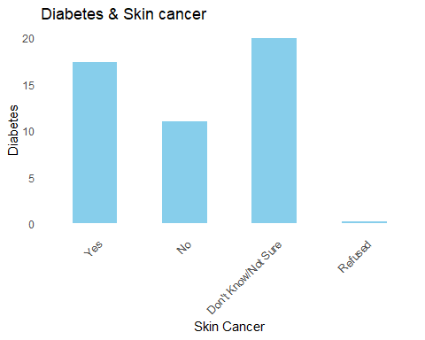

*#Diabetes and asthma*  
  
Dia_asthma <- **svyby**(**~**diabetes_mellitus, **~**asthma, data_design, svymean, na.rm = TRUE)  
  
  
*#calculate Confidence Interval*   
dia_asthma_ci <- **confint**(Dia_asthma)  
  
*#The value of dia_asthma_ci gives the result of all the outcome variables to get the exact prevalence, we created a subset of the first 4 rows where diabetes = yes.*  
  
dia_asthma_ci_subset <- dia_asthma_ci[1**:**4,]  
  
*# Combine the results*  
dia_asthma_results <- **data.frame**(  
 Asthma = Dia_asthma**$**asthma,  
 diabetes = Dia_asthma**$**diabetes_mellitusYes **\*** 100,  
 diabetes2 = Dia_asthma**$**`diabetes_mellitusYes, but female told only during pregnancy `**\***100,  
 CI_Lower = dia_asthma_ci_subset[, 1] **\*** 100,  
 CI_Upper = dia_asthma_ci_subset[, 2] **\*** 100  
)  
  
  
  
*# Print results*   
**for**(i **in** 1**:nrow**(dia_asthma_results)) {  
 **cat**(dia_asthma_results**$**Asthma[i], ":",   
 **format**(**round**(dia_asthma_results**$**diabetes[i], 1), nsmall = 1), "%",  
 "(95% CI:",   
 **format**(**round**(dia_asthma_results**$**CI_Lower[i], 1), nsmall = 1), "-",  
 **format**(**round**(dia_asthma_results**$**CI_Upper[i], 1), nsmall = 1), "%)**\n**")  
}

## 1 : 14.8 % (95% CI: 14.2 - 15.4 %)  
## 2 : 10.8 % (95% CI: 10.6 - 11.0 %)  
## 3 : 9.4 % (95% CI: 7.2 - 11.6 %)  
## 4 : 2.6 % (95% CI: -0.2 - 5.4 %)

*# Plot Diabetes by Asthma*   
**ggplot**(dia_asthma_results, **aes**(x = Asthma, y = diabetes)) **+**  
 **geom_bar**(stat = "identity", fill = "maroon", width = 0.5) **+**  
 **labs**(  
 title = "Diabetes & Asthma",  
 x = "Asthma",  
 y = "Diabetes"  
 ) **+**  
 **theme_minimal**() **+**  
 **theme**(axis.text.x = **element_text**(angle = 45, hjust = 1)) **+**   
 **theme**(panel.grid.major = **element_blank**(),  
 panel.grid.minor = **element_blank**())

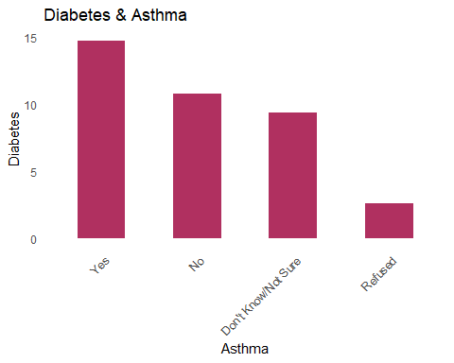

*#Diabetes and Arthritis*  
  
Dia_art <- **svyby**(**~**diabetes_mellitus, **~**arthritis, data_design, svymean, na.rm = TRUE)  
  
  
*#calculate Confidence Interval*   
dia_art_ci <- **confint**(Dia_art)  
  
*#The value of dia_art_ci gives the result of all the outcome variables to get the exact prevalence, we created a subset of the first 4 rows where diabetes = yes.*  
  
dia_art_ci_subset <- dia_art_ci[1**:**2,]  
  
*# Combine the results*  
dia_art_results <- **data.frame**(  
 Arthritis = Dia_art**$**arthritis,  
 diabetes = Dia_art**$**diabetes_mellitusYes **\*** 100,  
 diabetes2 = Dia_art**$**`diabetes_mellitusYes, but female told only during pregnancy `**\***100,  
 CI_Lower = dia_art_ci_subset[, 1] **\*** 100,  
 CI_Upper = dia_art_ci_subset[, 2] **\*** 100  
)  
  
  
  
*# Print results*   
**for**(i **in** 1**:nrow**(dia_art_results)) {  
 **cat**(dia_art_results**$**Arthritis[i], ":",   
 **format**(**round**(dia_art_results**$**diabetes[i], 1), nsmall = 1), "%",  
 "(95% CI:",   
 **format**(**round**(dia_art_results**$**CI_Lower[i], 1), nsmall = 1), "-",  
 **format**(**round**(dia_art_results**$**CI_Upper[i], 1), nsmall = 1), "%)**\n**")  
}

## 1 : 20.3 % (95% CI: 19.9 - 20.8 %)  
## 2 : 8.3 % (95% CI: 8.1 - 8.5 %)

*# Plot Diabetes by Arthritis*   
**ggplot**(dia_art_results, **aes**(x = Arthritis, y = diabetes)) **+**  
 **geom_bar**(stat = "identity", fill = "pink", width = 0.5) **+**  
 **labs**(  
 title = "Diabetes & Arthritis",  
 x = "Arthritis",  
 y = "Diabetes"  
 ) **+**  
 **theme_minimal**() **+**  
 **theme**(axis.text.x = **element_text**(angle = 45, hjust = 1)) **+**   
 **theme**(panel.grid.major = **element_blank**(),  
 panel.grid.minor = **element_blank**())

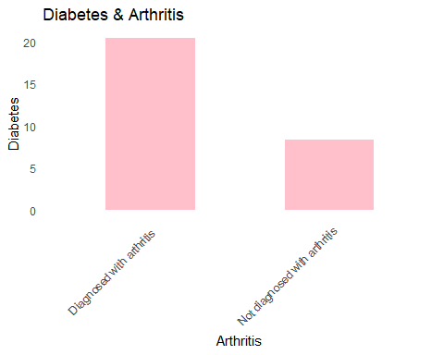

*#Diabetes and HIV/AIDS*  
  
Dia_hiv <- **svyby**(**~**diabetes_mellitus, **~**hiv_aids, data_design, svymean, na.rm = TRUE)  
  
  
*#calculate Confidence Interval*   
dia_hiv_ci <- **confint**(Dia_hiv)  
  
*#The value of dia_hiv_ci gives the result of all the outcome variables to get the exact prevalence, we created a subset of the first 4 rows where diabetes = yes.*  
  
dia_hiv_ci_subset <- dia_hiv_ci[1**:**4,]  
  
*# Combine the results*  
dia_hiv_results <- **data.frame**(  
 HIV_AIDS = Dia_hiv**$**hiv_aids,  
 diabetes = Dia_hiv**$**diabetes_mellitusYes **\*** 100,  
 diabetes2 = Dia_hiv**$**`diabetes_mellitusYes, but female told only during pregnancy `**\***100,  
 CI_Lower = dia_hiv_ci_subset[, 1] **\*** 100,  
 CI_Upper = dia_hiv_ci_subset[, 2] **\*** 100  
)  
  
  
  
*# Print results*   
**for**(i **in** 1**:nrow**(dia_hiv_results)) {  
 **cat**(dia_hiv_results**$**HIV_AIDS[i], ":",   
 **format**(**round**(dia_hiv_results**$**diabetes[i], 1), nsmall = 1), "%",  
 "(95% CI:",   
 **format**(**round**(dia_hiv_results**$**CI_Lower[i], 1), nsmall = 1), "-",  
 **format**(**round**(dia_hiv_results**$**CI_Upper[i], 1), nsmall = 1), "%)**\n**")  
}

## 1 : 10.5 % (95% CI: 10.1 - 10.8 %)  
## 2 : 12.0 % (95% CI: 11.7 - 12.3 %)  
## 3 : 12.8 % (95% CI: 11.8 - 13.8 %)  
## 4 : 5.3 % (95% CI: 3.6 - 7.0 %)

*# Plot Diabetes by HIV/AIDS*   
**ggplot**(dia_hiv_results, **aes**(x = HIV_AIDS, y = diabetes)) **+**  
 **geom_bar**(stat = "identity", fill = "red", width = 0.5) **+**  
 **labs**(  
 title = "Diabetes & HIV/AIDS",  
 x = "HIV/AIDS",  
 y = "Diabetes"  
 ) **+**  
 **theme_minimal**() **+**  
 **theme**(axis.text.x = **element_text**(angle = 45, hjust = 1)) **+**   
 **theme**(panel.grid.major = **element_blank**(),  
 panel.grid.minor = **element_blank**())

